EMBEDDED SYSTEMS INTERNSHIP REPORT
SMART LIGHTING AUTOMATION SYSTEM USING ARDUINO UNO AND PHOTOTRANSISTOR
Submitted By: Meenakshi Kumari Patro
College: Aditya institute of technology and management, Tekkali

- INTRODUCTION
A Smart Lighting Automation System is an embedded system project that automatically controls lighting based on the surrounding light intensity. The system uses a phototransistor sensor to detect ambient light levels and an Arduino UNO to process the sensor data. Depending on the detected light intensity, the Arduino automatically turns an LED ON or OFF. This project demonstrates the concept of automation and real-time sensor monitoring in embedded systems.
- COMPONENTS USED
S.No | Component | Purpose
1 | Arduino UNO | Main Controller
2 | Phototransistor (Ambient Light Sensor) | Detects Light Intensity
3 | LED | Output Indicator
4 | 220Ω Resistor | Limits LED Current
5 | 10kΩ Resistor | Pull-Down Resistor
6 | Jumper Wires | Circuit Connection
7 | USB Power Supply | Provides Power

- CIRCUIT DIAGRAM
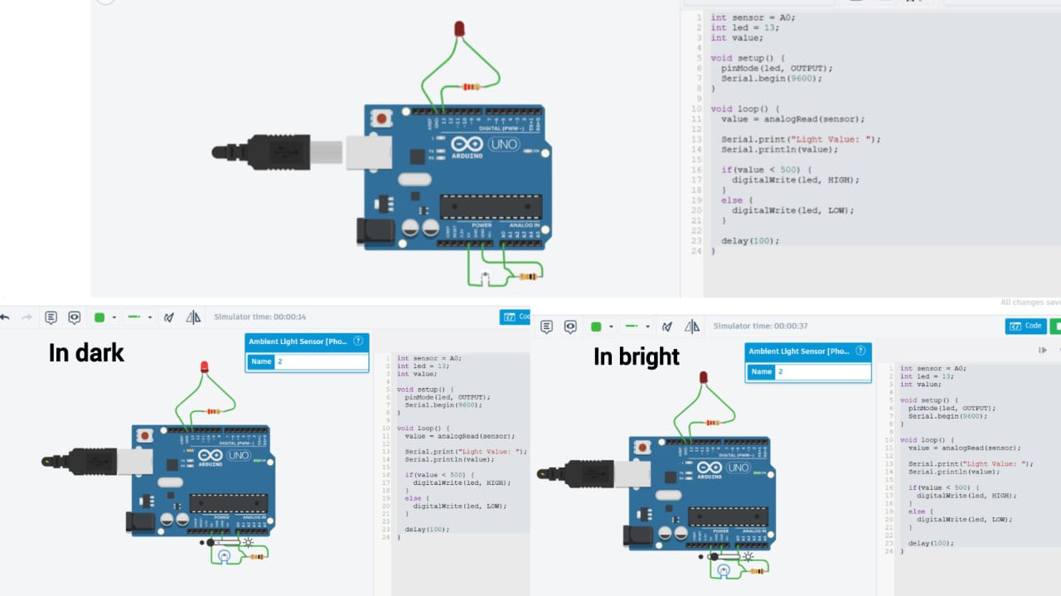

- ARDUINO PROGRAM

int sensor = A0;
int led = 13;
int value;
void setup() {
pinMode(led, OUTPUT);
Serial.begin(9600);
}
void loop() {
value = analogRead(sensor);
Serial.print("Light Value: ");
Serial.println(value);
if(value < 500) {
digitalWrite(led, HIGH);
}
else {
digitalWrite(led, LOW);
}
delay(100);
}

- WORKING PRINCIPLE
The phototransistor senses the surrounding light intensity and produces a corresponding electrical signal. Arduino UNO reads this signal through analog pin A0 and converts it into a digital value. The sensor value is displayed on the Serial Monitor for monitoring purposes.
The program continuously compares the sensor value with a predefined threshold value. When the ambient light level decreases below the threshold, the Arduino automatically turns ON the LED. When the ambient light level increases above the threshold, the LED turns OFF. This creates an automatic lighting system that responds to environmental conditions in real time.

- APPLICATIONS
• Automatic Street Lighting Systems
• Smart Home Lighting Automation
• Garden Lighting Systems
• Energy Saving Applications
• Industrial Lighting Control
• IoT-Based Smart Lighting Projects

- CONCLUSION
The Smart Lighting Automation System using Arduino UNO and Phototransistor was successfully designed and simulated in Tinkercad. The system effectively monitors ambient light intensity and automatically controls an LED based on the detected light level. This project demonstrates the practical implementation of sensor interfacing, automation logic, and embedded system design principles used in real-world smart lighting applications.

